**FACTORS AFFECTING EFFECTIVE IMPLEMENTATION OF PROJECTS BY NGOS IN SOUTH SUDAN: THE CASE OF JOHNANNITER INTERNATIONAL ASSISTANCE**

**BY**

**PETER ATEM ANYUON**

**Aipms/290/2019**

**A PROPOSAL PRESENTED TO THE AFRICA INSTITUTE FOR PROJECT MANAGEMENT STUDIES IN PARTIAL FULFILLMENT OF THE REQUIREMENTS FOR THE AWARD**

**OF POST GRADUATE DIPLOMA IN MONITORING AND EVALUATION OF**

**AFRICA INSTITUTE FOR PROJECT MANAGEMENT STUDIES**

**(AIPMS)**

**OCTOBER, 2019**

**DECLARATION**

This research project report is my original piece of academic work and to the best of my knowledge has

Not been presented for any award in this or any other university.

**Signed** **………………………………. Date: ……………………………….**

**Peter Atem Anyuon**

**Aipms/290/2019**

This research project report has been submitted for examination

Supervisor.

**Signature: ……………………………Date: ……………………………….**

**Supervisor**

**Mr. Ratemo Fredrick**

**Department of Distance Studies**

**Africa institute for project management studies in Nairobi**

ii

**DEDICATION**

I dedicate this research project report to my lovely Son **Anyuon Atem** and my wife **Roda Aluel** for their constant encouragement and support during the entire period.

iii

**ACKNOWLEDGEMENT**

This work would have not been possible without my Supervisor, **Mr. Ratemo Fredrick**

Who provided much needed direction, correction, mentorship and assistance in the course of doing this research? I acknowledge his support and thank him most sincerely for his tireless efforts.

I also appreciate the most important people such as my boss **Peter Kerugma** and **Lucy** for their counsel, mentorship and the invaluable guide throughout my whole studies and this research. Also my appreciations go to my co-workers, the **(AIPMS)**

Library staff and class of 2019 Provided good academic company even through the hard times when material for study was hard to come by. Their togetherness through the discussions has made this project a reality.

My utmost appreciation and honor I bequeath to dear God for his wisdom, inspiration and guidance.

TABLE OF CONTENTS

DECLARATION……………………………………………………………………………….. ii

DEDICATION…………………………………………………………………………...............iii

ACKNOWLEDGEMENT……………………………………………………………………… iv

TABLE OF CONTENTS……………………………………………………………………….. v

LIST OF FIGURES…………………………………………………………………………….. vii

LIST OF TABLES……………………………………………………………………………… viii

LIST OF ABBREVIATIONS…………………………………………………………………... ix

ABSTRACT……………………………………………………………………………………... x

CHAPTER ONE………………………………………………………………………………… 1

INTRODUCTION………………………………………………………………………………. 1

1.1 Introduction 1

1.1 Background 1

1.1.2 The Children of Wau Foundation 3

* 1. Statement of the Problem 4
  2. Objective of the Study 5
  3. Research Questions 6
  4. Significance of the Study 6
  5. Limitations of the Study 7
  6. Scope of the Study 7

CHAPTER TWO 8

LITERATURE REVIEW 8

* 1. Introduction to Literature Review 8
  2. Past studies / main Review 8
  3. Summary and gaps to be filled by the study 25
  4. The Conceptual Framework 26

CHAPTER THREE 27

RESEARCH METHODOLOGY 27

* 1. Introduction 27
  2. Research Design 27
  3. Target population 27
  4. Sample design 28
  5. Data collection procedures 28
  6. Data Analysis 29
  7. Expected output 29

CHAPTER FOUR 31

DATA ANALYSIS ……………………………

* 1. Introduction 31
  2. Demographic Statistics 31
  3. Implementation of Strategies of Wau Foundation 33
  4. Funding 37
  5. Training 40
  6. Organization Structure 42
  7. Stakeholders Involvement 44

CHAPTER FIVE: SUMMARY, CONCLUSION AND RECOMMENDATIONS 46

* 1. Introduction 46
  2. Summary of the Findings 46
  3. Conclusions 48
  4. Recommendations 50
  5. Recommendation for Further Study 50

REFERENCES 51

Appendices 55

Appendix 1: Introduction Letter 55

Appendix I: Questionnaire 56

# LIST OF FIGURES

Figure 1.1: Wau Foundation Organizational Chart 4

Figure 2.2: The Conceptual Framework 26

Figure 4.1: Implementation of Strategies of Wau Foundation 34

Figure 4.2: Timeliness in the Implementation of strategies 34

Figure 4.3: Accuracy of Implementation of Strategies 35

Figure 4.4: Strategies Implementation consistency with the needs of the beneficiaries 36

Figure 4.5: Stakeholders Involvement in Strategies implementation 36

Figure 4.6: Effectiveness of the Process of Strategy Implementation 37

Figure 4.7: Sufficiency of Financial Support from donors 38

Figure 4.8: Conditions of the funding 38

Figure 4.9: Extent to Which Funding Had Affected Project Implementation 40

Figure 4.10: Training 40

Figure 4.11 Training Staff of Specialized Skills 41

Figure 4.12: Effectiveness of the trainings offered 42

Figure 4.13: Organization Structure 42

Figure 4.14: Extent that organizational structure affected project implementation 44

Figure 4.15: Stakeholders Involvement 44

Figure 4.16: Extent to which stakeholder involvement affected project implementation 45

# LIST OF TABLES

Table 3.1: Sample Size 28

Table 4.1: Gender Distribution of the Respondents 31

Table 4.2: Level of Education of Respondents 32

Table 4.3: Current Designation in the Organization 32

Table 4.4: Period Worked Within the NGO 33

Table 4.5: Effects of Funding on the Implementation of Projects 39

Table 4.6: Organization Structure 43

|  |  |
| --- | --- |
|  | **LIST OF ABBREVIATIONS** |
| WB | : World Bank |
| MDPs | : Major Development Partners |
| EU | : European Union |
| IFC | : International Financial Corporation |
| GTZ | : German Technical Cooperation |
| DANIDA | : Danish International Development Agency |
| SIDA | : Swedish International Development Agency |
| NGO | : Non-Governmental Organization |
| UN | : United Nations |
| U.S. | : United States |
| UK | : United Kingdom |
| USAID | : United States Agency for international Development |
| UNDP | : united Nations Development Programme |
| NCTAF | : National Commission of Teaching and America‟s Future |
| PMI | : Project management Institute |
| CSR | : corporate social responsibility |
| GNP | : Gross national product |

# ABSTRACT

Non-Governmental Organizations (NGOs) face various challenges in the implementation of their projects. This study seeks to establish the factors affecting the successful implementation of projects in NGOs within urban slums in South Sudan. To achieve this objective, the study was guided by the following specific research objectives: finding out how funding affects implementation of projects of Children of Wau Foundation; establishing the effect of training on implementation of projects of Children of Wau; establishing the effects of organization structure on implementation of projects of Children of Wau Foundation and establishing the effects of stakeholder relationships on the implementation of projects of Children of Wau Foundation. This study was limited to one NGO- the Children of Wau Foundation. As such the findings may not apply to other NGOs in South Sudan because of the uniqueness of projects and project duration at the Children of Wau Foundation. This study adopted a descriptive research design. According to Cooper and Schindler (2003), a descriptive study is concerned with finding out the what, where and how of a phenomenon. The target population of this study included all the employees at the Children of Wau Foundation. As per the human resources records, there were 124 employees in the NGO. As at 31st December 2012. Following the high homogeneity among the respondents in the different strata, the study selected 30% of the target population for inclusion in the study. The collected data was analyzed using both quantitative and qualitative data analysis methods. Quantitative method involved both descriptive and inferential analysis. Descriptive analysis such as frequencies and percentages were used to present quantitative data in form of tables and graphs. Descriptive statistics involves the use of absolute and relative (percentages) frequencies, measures of central tendency and dispersion (mean and standard deviation respectively).The study also established that the strategies were implemented on time. The respondents explained that strategy implementation was influenced by several factors key among them the availability of financial resources to see the strategy implementation to the end. The study also concludes that the organization structure of Wau Children Foundation affected the strategy implementation process. The study also concludes that stakeholder’s involvement affected project implementation at the Foundation. The study recommends that the Foundation engages the stakeholders more to harmonize its goals and objectives with the aspirations of the stakeholders and reduce dissonance levels thereby increasing satisfaction. To enables employees deliver quality services, the study recommends that the Foundation hires qualified staff and in

Addition, it trains them to enable them deliver services optimally. The study recommends that the Foundation involves stakeholders in all its strategic management right from strategic formulation to strategic evaluation. This will reduce the levels of resistance hence promote strategy implementation processes.

# CHAPTER ONE

# INTRODUCTION

# 1.1 Overview

This study will examine factors affecting the effective implementation of projects by NGOs in South Sudan with special reference to Joanniter International Assistance. NGO projects are those that aim at improving the living conditions of people in the various communities where they operate by providing religious, educational, literary, agricultural, social or charitable support. This chapter this chapter presents an overview of the background to the study and statement of the problem. It also focuses on the purpose and objectives of the study, research questions, scope of the study, significance of the study and justification for the study. The chapter will end with operationalization of the unfamiliar terms the researcher will use in the course of the study

# 1.2 Background of the Study

This section presents a descriptive account of the general background to the study. This is broken down into four dimensions namely: historical background, theoretical background, conceptual background and contextual background as shown in sub-sections 1.2.1 – 1.2.4 below.

## 1.2.1 Historical Background

A project in its basic definition is a temporary endeavor undertaken by people who work cooperatively together to create a unique product or service (Project Management Institute, 2017) within an established time frame and within established budget to produce identifiable deliverables. Project success has been defined by the criteria of time, budget and deliverables (Flagman and Gallagher, 2016). According to Antill (2014), a project is only successful if it comes on schedule, on budget, it achieves the deliverables originally set for it and it is accepted and used by the clients for whom the project was intended. According to Boyce and Haddad (2011), projects possess certain characteristics that distinguish them from any other activity in the organization. These include the fact that projects are temporary meaning that any project will have a start date and end date although it has nothing to do with short duration. Another feature is that projects produce unique results meaning that the product or service at the end of the project should be some way different than the existing. The other characteristic is that projects are characterized by progressive elaboration due to uniqueness and greater uncertainty projects cannot be understood entirely at or before project start, and therefore planning and execution of projects is happening many times in separate steps or phases. As project progresses, project team understands the steps to follow, deliverables and way of executing them much better. Based on this knowledge team member elaborate initial draft plans, and execute next phase of the project based on these detailed plans.

## 1.2.2 Theoretical Background

This study will be guided by public goods theory (Gariyo, 2007). Gariyo (2002) put forward the public goods theory which states that NGOs exist to satisfy the residual unsatisfied demand for public goods in society as the state tends to provide public goods only at the level that satisfies the average voter. Where a significant minority wants a kind or a level of public goods for which the majority support is lacking, the government cannot help, and NGOs step in to fill the gap. Where some parts of the population may want more public goods than the government is willing to provide, they then organize themselves, demanding more social services for their particular group, organizing their own community schools, or mobilizing local people for a collective campaign of some sort.

The World Bank (2010) similarly observed that a comprehensive strategy of development is simply too demanding for any one level or area of government or for a single donor to adequately address and hence the NGOs come in as an important constituent of the civil society sector. World Bank (2010) describes NGO's as organizations which aim to promote social and economic change. Non-governmental organizations are referred to as third sector organizations which exist to fulfill a number of functions in areas which tend to be neglected by the public sectors. The decline in public sector or governmental provision of services in some countries influenced the establishment of NGO's to play an increasingly influential role in a variety of activities which impact upon the lives of many people. Gariyo (2007), alludes to the fact that NGO activity extends to lobbying private and public sector organizations which includes governments and other regulators. The role of NGOs in relation to development theories are the impact of these organizations in social and economic context.

## 1.2.3 Conceptual **B**ackground

Competence refers to effective performance within a domain/context at different levels of proficiency (Cheetam and Chivers, 2015). Turner and Mu¨ller (2015), argue that the project manager competence should be taken into account when assigning a project manager to a project. The fact that manager competence is crucial for project success has been echoed by scholars like Driver et al. (2016), who agrees with the above fact by indicating that manager competence is important in the project implementation. In a research carried out by Müller and Turner (2010), it was found that; manager competences correlate directly with project success measures especially, competences in managing project resources.

Miller& Shinn (2015) defines community involvement as the process of working collaboratively with and through groups of people affiliated by geographic proximity, special interest, or similar situations to address issues affecting the well-being of those people. It often involves partnerships and coalitions that help mobilize resources and influence systems, change relationships among partners, and serve as catalysts for changing policies, programs, and practices.

Kapucu (2015) defines inter-organizational coordination as managing capability of inter-organizational collaborations and relationships, which can be in many forms including inter-organizational teams, partnerships, alliances and networks. Intra-organizational coordination, on the other hand, is the mutual influence of working processes of two or more actors who work within the same organization in order to attain a certain objective (Liaquat & Uddin, 2012).

## 1.2.4 Contextual Background

Johanniter International (JOIN) is an international network of charities affiliated to the [Alliance of the Orders of Saint John of Jerusalem](https://en.wikipedia.org/wiki/The_Alliance_of_the_Orders_of_St._John_of_Jerusalem). Founded in 2000 and with headquarters in [Brussels](https://en.wikipedia.org/wiki/Brussels), [Belgium](https://en.wikipedia.org/wiki/Belgium), its 20 member organizations are located in [Europe](https://en.wikipedia.org/wiki/Europe) and the [Middle East](https://en.wikipedia.org/wiki/Middle_East) and focus on emergency rescue, health and social services, and international humanitarian assistance, amongst other aims. Together, the charities have a volunteer base of over 100,000 persons at their disposal. JOIN’s primary goal lies in facilitating exchange of [best practices](https://en.wikipedia.org/wiki/Best_practice#Use_in_health_and_human_services) between its members, achieving closer cooperation among its members on the European and international level, and advocating for the interests of its members on the European basis

Since 2011, Johanniter is active in South Sudan, implementing projects to enhance the nutrition status of malnourished children, mothers and pregnant women, improving hygiene practices in local communities and providing basic medical care. Long-term approaches in agricultural extension are contributing to increase food security while helping to improve livelihoods of the people.

# 1.3 Statement of the Problem

Despite the question for effective implementation of projects, many Non-Governmental organizations’ projects in South Sudan have continuously experienced time overrun, budget overrun, unmet end product specifications, unmet customer needs and requirements and unmet management objectives (South Sudan NGO report, 2018). The high failure rate in Non- Governmental Organizations’ projects could be due to poor manager competencies (Scott-Young & Samson, 2014), lack of community involvement and poor coordination of the various activities. This study therefore aims at finding out the factors affecting effective implementation of projects by NGOs in South Sudan

**1.4 Main Objective**

The purpose of the study is to assess the factors affecting effective implementation of projects by NGOS in South Sudan: the case of Johnanniter International Assistance.

# 1.4 Specific Objectives of the Study

1. To examine the relationship between project manager competencies and effective project implementation at the Johanniter International Assistance
2. To identify the relationship between community involvement

# 1.5 Research Questions

1. What is the relationship between project manager competencies and effective project implementation at the Johanniter International Assistance?
2. What is the relationship between community involvement and effective project implementation at the Johanniter International Assistance?
3. What is the relationship between coordination and effective project implementation at the Johanniter International Assistance?

# 1.6 Hypothesis of the research

H1: There is a relationship between project manager competencies and effective project implementation at the Johanniter International Assistance

H2: There is a relationship between community involvement and effective project implementation at the Johanniter International Assistance.

H3: There is a relationship between coordination and effective project implementation at the Johanniter International Assistance.

1.7 CONCEPTUAL FRAMEWORK

**Effective project implementation**

(Dependent Variable)

Organizational Performance

**Factors of project success**

(Independent Variables)

**Manager Competency**

* Training capacity
* Staffing capacity
* Visioning. Leading and governance capacity

**Community Involvement**

* Airing their views
* Discussions
* Ownership

**Coordination**

* Standardization
* Coordination by plan
* Direct supervision

**Project implementation**

* Cost mitigation
* Time management
* Quality of output
* Scope

**Moderating Variables**

* Culture of motivation decision making
* Institution rules and regulations

Source; Researcher 2019

The conceptual framework has focused on both Dependent and Independent Variables that is to say Effective Project Implementation and factors that influence success of projects respectively. The independent variables will focus on Competences of the managers especially their training capacity, staffing capacity, visioning, and Leading and governance capacity.

Community Involvement will be another independent variable that the researcher will refer to especially airing out their views by different people, discussions and ownership and people accepting to be responsible for different executions.

The other Independent variable that the researcher will look at is coordination but with emphasis on Standardization, coordination by plan and also direct supervision.

For dependent variables, the researcher will be specifically looking forward to know how the implementation of projects is achieved but with more attention on Cost mitigation, time management, quality of output and Scope.

The above variables will guide the researcher properly to stay on track as they carry out the investigations, however, the researcher will put into consideration the moderating variables of Culture of motivation decision making and Institution rules and regulations

# 1.8 Significance of the study

The findings of the study will be of great importance to Johanniter International Assistance to direct more research related fields like to find out the factors affecting effective project implementation and it will act as a reference material for the many institutions.

The findings of this study will benefit managers and practitioners of Non-governmental Organizations in being able to design appropriate policies, strategies and operational tactics.

On my side as the researcher, the study will be a basis for academic award as it is due to the submission of this research proposal that I will be awarded a Diploma in monitoring and Evaluation of Africa institute for project management studies.

Finally, the findings of this study will be of great value to both the researcher and future academicians/researchers since it acts as a reference source for a related study.

# 1.9 Justification of the study

The research is will be conducted to assess the factors affecting effective project implementation. Researchers and students in this field will find new models of understanding how manager competences, community involvement and coordination influence implementation of Non-Governmental Organizations globally and especially in Wau South Sudan thereby contributing to the body of knowledge and existing literature for further researchers with interest in Non-governmental Organizations.

Advance generation of more information on the other aspects of project manager competence, community involvement and coordination and identify which specific elements of these variables actually influence implementation so that specific policy, strategic and tactical actions are put in place by Non-Governmental Organizations, researchers and practitioners to enhance implementation of Non-Governmental projects.

# 1.10 Scope of the study

## 1.10.1 Geographical scope

The study will be conducted at Johanniter International Assistance located in Juba city, South Sudan. This place is chosen because it holds information that is of interest to the research.

## 1.10.2 Time scope

The research will consider information from the time JOIN established its operations in southern Sudan that is 2011 to date. This is on a premise that this time will be long enough inform the study of the achievements the institution has been in position to observe so as to critically assess the management competences.

## 1.10.3 Content scope

The research will concentrate on determining the factors affecting effective project implementation by NGOs in South Sudan. The main focus will therefore be on manager capacity, community involvement and coordination as factors affecting project implementation but with special attention to Johnanniter International Assistance as the case study.

# 1.11 Operational definitions

**Competence**

According to Cheetam and Chivers (2015), Competence refers to effective performance within a domain/context at different levels of proficiency.

**Community involvement**

This is defined as the process of working collaboratively with and through groups of people affiliated by geographic proximity, special interest, or similar situations to address issues affecting the well-being of those people. It often involves partnerships and coalitions that help mobilize resources and influence systems, change relationships among partners, and serve as catalysts for changing policies, programs, and practices (Miller& Shinn 2015)

**Coordination**

According to Akrani (2011), coordination leads to unity of action and is the essence of management because it affects all functions of management namely, organizing, planning, staffing, controlling, communication and leading, which at the end results to effective implementation of given projects.

# CHAPTER TWO

# LITERATURE REVIEW

# 2.1 Overview

This chapter presents the theoretical framework, the conceptual framework and review of related literature and also gives views about what other authors have written about the topic and the review is to take the form of the objectives so that other author’s contribution in related literature is recognized in this chapter.

## 2.1.1 Theoretical Review

(2015) indicates that as firms grow and evolve from small to larger and multidivisional organizations, the strategy implementation methods also evolve simultaneously. The various strategy implementation models described by Bourgeois (2014) are meant to meet the changing needs of firms as they evolve through various stages of the organizational life cycle 2015). In contrast to the earlier descriptive models, this model is more prescriptive with an, albeit limited, empirical basis. Their research highlights three of Bourgeois (2014) classifications of strategy implementation styles: change, collaborative, and cultural.

Not all firms implement their strategies in the same manner; nevertheless, research investigating the differing styles of implementation is scarce. Nutt (2015) utilizes Jungian theory (Jung, 1923) for his framework of implementation style; however, this is very much an analysis of the psychological style of individuals within the firm. More recently, (2015) utilized Bourgeois (2014) classification of strategy implementation types.

The majority of extant taxonomy models in strategy implementation tend to be normative in nature 2015). Alternatively, they are developed from organizational observation, and as such, become context specific and frequently lack any broader theoretical grounding (Hooley et al., 2012). In contrast, Bourgeois (2014) model is comprehensive, is based on specific theoretical assumptions and has been used by authors such (2015). Bourgeois (2014) to refute the traditional approach to strategy implementation as simply an adjunct to the strategy formulation phase of the strategy process. Rather, they contend that strategy implementation evolves either from a process of winning group commitment through a coalitional form of decision-making, or as a result of complete coalitional involvement of implementation staff through a strong corporate culture

# 2.2 Thematic Review

This sub section presents the review of literature according to the various themes as represented by the specific objectives for easier comparison and assessment. That is competence of management, community involvement and coordination and effective project implementation.

# 2.2.1 Project Manager Competences and effective project implementation

Competence refers to effective performance within a domain/context at different levels of proficiency (Cheetah and Chives, 2015). Turner and Muller (2015), argue that the project manager competence should be taken into account when assigning a project manager to a project. The fact that manager competence is crucial for project success has been echoed by scholars like Diver et al. (2006), who agrees with the above fact by indicating that manager competence is important in the project implementation. In a research carried out by Müller and Turner (2010), it was found that; manager competences correlate directly with project success measures especially, competences in managing project resources.

Hang and Moe (2008), found that the critical success factor for project implementation is the project manager competence in the planning of the project activities and how resources will be utilized. This is in line with Kearns (2007), who examined the impact of project planning on projects. He found out that planning is vital for the successful implementation of projects. In a study by Havarti (2006), it was found out that there is a positive correlation between manager competence and performance. They aver that manager skills, knowledge and abilities are important competences that are needed for successful implementation of projects.

On the question of what managerial competences are perceived to be important for effective project implementation?, a study by Havarti (2006), revealed that effective communication competence ranked highest while competences related to technical and conceptual skills ranked lowest. Studies of successful project managers identified success factors, as the ability to manage people, stress, and communications (Sumner, et al., 2006). The applicability of the transformational leadership model developed by Bass & Avolio (1997), was tested by Tithe (2012), and his findings revealed that the more successful project managers exhibited greater degree of leadership behavior than did less successful project managers. The application of leadership as a critical success factor assumes added significance because the nature of project teams is typified by role conflict and role ambiguity. These factors make the challenge of managing project teams rather substantial (Sumner, et al. 2016).

Successful project outcomes result from a project manager delivering quality outputs in time through the efficient utilization of allocated resources for a project (Bester, & Hobbs, 2016). The success of a project hinges on the ability of the project manager to ensure timely delivery, adhere to budget constraints, manage scope and quality specifications (Schmidt & Adams, 2008), and meet stakeholder expectations (Project Management Institute, 2008). The project manager must display the requisite leadership skills that are essential for the implementation of a successful project, in addition to having the requisite skills to guide a project team through the various phases and project cycles (Gehrig, 2017). The project manager’s ability to successfully lead a team and achieve goals is and will always be critical to the success of a project (Hyvari, 2016). Project managers use management skills such as defining problems, planning work, allocating resources, and controlling tasks.

However, these skills are inadequate for building the human relations skills of, encouraging innovation, and empowering the project team to perform creatively and effectively throughout the project (Schmidt & Adams, 2008). Havarti (2016), found out that there was an agreement among researchers that the most important cause of project success or good performance was managerial competence. Cleland (2014), cited the following as reasons for effective project implementation; effective planning, appropriate organizational design, well defined and delegated authority and responsibility, efficient systems for monitoring, evaluating and controlling the use of resources on the project and effective contingency planning all of which are attributed to project manager competence.

# 2.2.2 Community Involvement and Effective Project Implementation

From a systems perspective, a community is similar to a living creature, comprising different parts that represent specialized functions, activities, or interests, each operating within specific boundaries to meet community needs. For the community to function well, each part has to effectively carry out its role in relation to the whole organism. A healthy community has well- connected, interdependent sectors that share responsibility for recognizing and resolving problems and enhancing its well-being. Individuals have their own sense of community membership that is beyond the definitions of community applied by researchers and engagement leaders. Individual sense of membership can change over time and may affect their participation in community activities (Winkler et al, 2014).

Miller& Shinn (2015), defines community involvement as the process of working collaboratively with and through groups of people affiliated by geographic proximity, special interest, or similar situations to address issues affecting the well-being of those people. It often involves partnerships and coalitions that help mobilize resources and influence systems, change relationships among partners, and serve as catalysts for changing policies, programs, and practices. Brett (2015), asserts that the main factor contributing to project success is community involvement during all phases of the project, especially the planning and design phases. To him community involvement in the project would impart ownership of the project to the community by ensuring the availability of the needed resources for the project implementation. According to Magnolia (2010), it was found out that, when the societies within which Non-governmental organizations operates are in support of its projects, the organization incurs lower cost on implementation of such projects.

This could be in terms of the locals availing some free labor during implementation. It could be in form of having locals actively pass on the information to other locals at no cost. In Northern Uganda, the successful implementation of Action Aid projects was partly attributed to community involvement. The community participated in these projects by provision of resources such as; land, bricks, sand, hardcore and labor (Action Aid Report on performance, 2010). Nay ET. al. (2010), argues that collaborations (that are characteristic of social networks) improve performance through enabled resource acquisition. This implies that Project teams can cheaply source new and vital information through collaborations with the community (Rosenthal, 2017). Brett (2015), however, contends that failure to adequately involve the community can cause considerable delays as a result of community reluctance or outright opposition to the project. Chavez ET. al. (2017), argues that limited success of many projects is due to the communication gap between the local communities and the project planners. To Chavez et. al. (2017), community involvement should include a complete and total transfer of information from all of the parties involved to ensure that tradeoffs are adequately explained and decisions can be made based on the fullest possible set of data available at the time.

# 2.2.3 Coordination and Effective Project Implementation

Since there are many individuals, groups and departments in organizations, coordination becomes a very important means of integrating the various activities in order to achieve the objectives of the organization (Lyre & Johan 2015). According to Karana (2011), coordination leads to unity of action and is the essence of management because it affects all functions of management namely, organizing, planning, staffing, controlling, communication and leading, which at the end results to effective implementation of given projects.

Coordination facilitates social interactions where multiple actors work towards achieving a common goal. Coordination is both at intra- and inter-organization level. Kapok (2015), defines inter-organizational coordination as managing capability of inter-organizational collaborations and relationships, which can be in many forms including inter-organizational teams, partnerships, alliances and networks. Intra-organizational coordination, on the other hand, is the mutual influence of working processes of two or more actors who work within the same organization in order to attain a certain objective (Liquate & Uddin, 2012).

Kapok, (2015), argue that, in a complex and dynamic environment, it is difficult for a single organization or actor to neither have sole responsibility of all responds nor be able to meet all demands immediately. Also, actors may spread over vast regions which may prove to be inappropriate for a single organization or actor to respond due to a lack of general coverage. According to (Karana, 2011), coordination improves goodwill of the organization by helping an organization to sell high quality goods and services at lower prices. The study by Kubrick et al (2017), states that coordination is a vital activity during the project implementation process. In this context, coordination and cooperation among members are a prerequisite to build up effective and efficient processes of implementation.

**2.4 Review of Empirical Studies**

The rapid pace of Globalization has led to a change in the global economy during the past several decades; it is believed that factors such as trade liberalization, access to cheaper labor and resources, similarity of consumer demand around the world, and advances in technology and communication has widened the market of consumption, investment as well as production on a global scale. These globalization driven factors created new challenges and global competition for businesses around the world thus as a response many companies decided to expand their operation across national borders in order to be competitive. However, when company decides to internationalize their operation they will be exposed to various environment, culture, legal and po differences and in order to operate successfully they should be able to modify its products and services to meet the cultural preference of their foreign customer as well as able to adjust their operation to comply with the local legal requirement (Maybe, 2003).

Early operationalization of community development models had challenges, White (1999), notes that early results from among international development agencies funded projects, was such that, after the community had a requirement and the development aid given, then the development agency loses interest, leaving the program to collapse. This perception re-awakened interest in the notion of local management of resources and decisions. The participatory development movement led by Chambers (1983) and others was important in applying these ideas directly to small scale development. Their focus was on finding methods that would allow the poor to be informed participants in developmental assistance, with external agents mainly acting as sources of funds and facilitation. Supporting this was the increasingly strong and articulate critique of Development from academic social scientists such as Escobar (1995) and Scott (1998) attempting to demonstrate how top down perspectives both dis-empowering and UN effective were.

According to Müller & Tuner (2005), project managers should not be given tasks of which they are not competent at, but instead they should be given further training and development in those areas where they show incompetence so as to gain sufficient practical experience prior to another assignment. They also recommended that, where staffs are not yet competent when undertaking project work, they should be supervised by a currently competent person. The supervisor should control the activities undertaken, check that the activity has either been carried out correctly or ensure that any necessary corrective action is taken, and take overall

Responsibility for the work. Thompson et al.,(2000) assert that project manager competences is reflected in his ability to negotiate, advocate, explain, connect, prove and convince the different stakeholders and assure them of the added value of trying something new. The effective project manage r will never stick to one version of her „truth‟. Truth is contextual and can be sold in different ways to different stakeholders. Particularly when the project manager already has access to resources that would support his specification of alternatives, windows of opportunity may more readily be opened. A project’s success is, in part, contingent on effectively managing the constraints of time, costs,

And performance expectations. In order to achieve this it is essential that the project manager possess a d display appropriate leadership skills (Cleland, 2004) Sumner, et al., 2006) as sited in Havarti, (2006). By applying the appropriate leadership attributes such as balance, proficiency, persistence, sound decision making, imagination, vision, values, integrity, trust, and sincerity a project manager could direct projects effectively and efficiently ( Schmidt & Adams, 2008).

Kubrick et al. (2007), claim that the success of project implementation is characterized by relations between participants. Peacock et al (1996, 1997) have the same opinion that a sufficient level of interaction between the community members and project officers brings success to the overall project performance. Hence, coordination is more needed for such environment to build up teamwork and integration working environment, and it is fundamentally necessary for ensuring the success of a project. This claim I s supported by Dutton, J.E. and Happy, E.D (2003), who identifies coordination as crucial functions which discuss the implementation process. In this context, coordination is essential to improve the separate working environment through interaction and integration of the implementation stages. At the same time, coordination reduces the error and discrepancy throughout the overall process, thereby mitigating the likely time delays and incurred cost of rework. Lyre and Johan (2005) agree that coordination between project participants is the most significant factor with the greatest impact on cost performance. Accordingly, lack of coordination may cause duplicity of work and thus results in wasteful expenditures.

# 2.5 Synthesis and Gap Analysis

From the literature cited above it’s quite clear that with competent management devoted to the objectives of the respective institution as well as involvement of the community, there is a high proportionality for success. However, given the civil strife in southern Sudan and the lawlessness of the country the factors responsible for the performance of projects may go beyond the normal. This coupled with absence of such studies in the area justifies the need for this undertaking in order to have an informed out for future proper implementation of NGOs

(Source: Adopted from Maslow (1954) and modified by researcher (2018).

# CHAPTER THREE

# METHODOLOGY

# 3.1 Overview

This chapter will comprise of the methods that will be used in the whole research design where by mixed method that will include both qualitative and quantitative methods and this will mainly focus on the procedures that will be used in the study which include; the population coverage, include sampling data collection and cleaning and procedures.

# 3.2 Research Design

This is a [detailed](http://www.businessdictionary.com/definition/detailed.html) [outline](http://www.businessdictionary.com/definition/outline.html) of how an investigation will take place. A research design typically include how [data](http://www.businessdictionary.com/definition/data.html) is to be collected, what [instruments](http://www.businessdictionary.com/definition/instrument.html) will be [employed](http://www.businessdictionary.com/definition/employment.html), how the instruments will be used and the intended [means](http://www.businessdictionary.com/definition/mean.html) for analyzing data collected (Bacal, 2004). A case study design on both qualitative and quantitative aspects will be used. Case study method is useful for trying to test theoretical models by using them in real world situations (Glanz, 2002). This method will be preferred because it is an ideal method that eases the collection of information from the respondents at both individual and group levels. The researcher will use cross sectional design. Qualitatively, through exploratory design there will be research synthesis of literature review on research articles, essays, monographs, dissertations, and government documents on motivation of agricultural research staff that are available in the Sub-Saharan region. These sources have been conveniently selected among those proposed by Onwuegbuzie, Leech &Collins (2012) for representation and legitimation. This will enable identify appropriate motivational variables in the context of Non-government organizations, help researcher to distinguish what has been undertaken and what needs to be undertaken, identify contradictions and inconsistencies (Onwuegbuzie et al., 2012). The research findings will be displayed in table form with figures in percentage form. The researcher will go ahead to describe the findings from the tables.

The study will employ a cross sectional survey design because it is quick and given the nature of despondence for the period of study and the time constraint aspect. Furthermore this design is deemed appropriate since the study aims to establish the reasons behind the performance as opposed to testing a theory. The researcher will use a quantitative approach which will focus on describing and drawing inferences from the findings.

# 3.2 Study Population

Target population refers to the larger population to which the researcher ultimately would like to generalize the results of the study (Berg, 2011). It is therefore the entire group of individuals, events or objects having a common observable characteristic. The target population of study will be mainly the local and administrative staff in The Johanniter International Assistance South Sudan. The estimated number of respondents will be 70 from whom the researcher will select the sample. The researcher will attain information and data collection because the area seems to be wide.

# Sample size

The sample size will be calculated using the solvent’s formula for determining sample size as this gives a practical ratio according to the population size (Morgan and Klegcie, 1970). The researcher will divide the population (70) to 2 project coordinators and 68 staff. In this case a sample size of 60 will be used for the entire population of 70 as explained by Solvent’s Formula which states that, given a population, the minimum Sample size is given by:

*n= N* 1+N α2

Where

**n** = the sample size

**N =** total population of respondents, that is 70.

**α =** the level of significance, that is 0.05

**Table 1: Showing determination of the sample size**

|  |  |  |  |
| --- | --- | --- | --- |
| **Item** | **Target Population**  **N** | **Accessible Sample size**  **(n)** | **Sampling technique** |
| Coordinators | 2 | 2 | Purposive sampling |
| Staff | 68 | 58 | Simple random sampling |
| **Total** | **70** | **60** |  |

**Source**: Morgan and Klegcie (1970)

A sample size of 60 respondents will be selected to participate in the study.

## 3.3.1 Sampling procedure

A representative sample of the respondents will be selected from the total population to participate in the study.

The researcher will use simple random and purposive sampling techniques to choose the respondents to participate in the study.

With simple random it means that every member in the sample will have an equal chance of being selected, this will reduce on the biasness.

The. Also, with purposive sampling it means that information will only be obtained from the key informants who have ideas about the subject matter hence first-hand information will be obtained.

## Data sources

The study will use both primary and secondary data.

## Primary data

According to Domenici (2012), primary data is that kind of data that has been gathered from the first time, it has never been reported anywhere. It minimizes the shortcomings of secondary data sources such as datedness and inadequacy in terms of coverage. Self-administered questionnaires will be used and this will enable the researcher to cover a large population quickly and at a reasonable cost. Primary data in this case will be gathered basically through structured questionnaires and interviews. Involving the selection of respondents to provide information.

## Secondary data

Rested, (2010) defines secondary data as that kind of data that is available, already reported by some other scholars. Secondary data include policy documents and abstracts of the various scholars relating to the point of discussion in question. Secondary data for this research will be got from sources like libraries, records from The Johanniter International Assistance South Sudan, newspapers and magazines, online information, text books, and published research reports. This is because data in such sources is readily available and easier to comprehend, as it comprised of extensively researched work. Secondary data on the other hand will be gathered through review of available staff motivational factors like nature of works, appreciation and other branch publications.

# 3.5 Data Collection Methods and Tools

3.5.1 Data collection methods

The researcher will carry out field visits in a period of three weeks. In the first week, questionnaires will be distributed or dispatched to the respondents and later interviews will be carried out to obtain data from the respondents.

# 3.5.2 Data Collection Instruments

This study will comprise of two research techniques to collect data that is; data collection will be done using two methods, in-depth interviews will be conducted and questionnaires will also be administered to some respondents who can read and interpret the question.

## 3.5.2.1 Questionnaires

This is a technique in which the researcher gives a list of short questions to the respondents requesting them to fill and collect them later. Closed ended questions designed to suit the objectives will be used to effectively attain data for the study. The approved questionnaires will be hand delivered to the respondents of The Johanniter International Assistance South Sudan by the researcher and or any other research assistant to be appointed by the researcher. The researcher prefers this data collection instrument because it is the easiest way of collecting data from respondents compared to other data collection instruments. The researcher will design a questionnaire on 5 point scale rating. Therefore, a 5 point Likert scale self-administered questionnaire comprising of statements and responses ranging from: 5= Strongly Agreed, 4= Agreed, 3= Disagreed, 2= Not Sure 1. Strongly disagreed will be formulated. Questionnaires will be designed to capture all the aspects of the objectives of the study.

## 3.5.2.2 Interview schedule

The interview is one of the data collection methods. Rather than asking respondents to fill out questionnaires, interviewers ask questions orally and simultaneously record the respondents’ answers. This data collection method generally decreases the number of the respondents that do not know the answers compared with self-administered surveys. Interviewers also provide a guard against confusing items. If a respondent has misunderstood a question, the interviewer can clarify, thereby obtaining relevant responses. The researcher is intended in using this method of data collection because it gives foremost information from the respondents as in the researcher will personally get to the respondents and ask them questions directly related to the topic of study.

# 

# 3.6 Research procedure

The research will obtain an introduction letter from the Africa institute for project management studies. So that he is not mistaken as a spy but rather a graduate student seeking information on his research project. This will boost the confidence of the respondents and reduce of chancing of obtaining false despondence. Further there will be a pretest of the data collection tools to validate the instruments after approval from the supervisor

# 3.7 Data quality control

# 3.7.1 Validity

Amin (2005) defines validity as the appropriateness of the instrument. Experts in the field will be consulted about the content of instruments, ambiguity of question items and their relevancy. Validity is important in determining whether the statements in the questionnaire instrument and interview manuals are relevant to the study. Content and construct validity will be obtained by the help of the supervisors input who will act as reviewer during the report stage of the study. According to Amin (2004), validity can be and in this case will be assured by use of the Content Validity Index (C.V.I)

C.V.I= Agreed items by all judges as suitable

Total number of items being judged

# 3.7.2 Reliability

Reliability of data refers to whether repeating the same measurement under similar conditions yields the same results (Kumar, 1990). Reliability as the consistency of the instrument in measuring whatever it is intended to measure. The reliability of the questionnaires will be improved through pretesting of pilot samples from the field which enables the rephrasing of some questions. Additionally, reliability of the items will be done with the application of the Cronbach Alpha coefficient as illustrated below;

A= K 1- ∑SD2

K-1 ∑Dt2

Where A= Reliability, 1-∑SD2 =sum of the variance of the individual items in the questionnaire, ∑Dt2 =variance of the entire questionnaire, and K= Number of items in the questionnaire.

**3.8 Measurement of variables**

The independent variable for this study is staff motivation while organizational performance serves as a dependent variable. However there are other intervening variables which are assumed to affect organizational performance vis-à-vis staff motivation. All these variables are clearly shown under the conceptual framework in the chapter one of this study. The scale of both staff motivation and organizational performance will be measured on a 5 to 1 point scale such as (5 = Strongly Agreed, 4= Agreed, 3 = Disagreed, 2 = Not Sure, 1= strongly disagreed).

# 3.9 Data Analysis

Lehtonen, (2012) defines data analysis as the process of developing answers to questions through the examination and interpretation of data.  The basic steps in the analytic process consist of identifying issues, determining the availability of suitable data, deciding on which methods are appropriate for answering the questions of interest, applying the methods and evaluating. In this study, data analysis will be done in accordance with the above principles of data management.

## 3.9.1 Editing

Editing is the process whereby the completed questionnaires and interview schedules will be analyzed in the hope of amending recording errors or at least deleting data that is obviously erroneous. This is aimed at improving the quality of information from respondents. The researcher will fill out few unanswered questions. However, the answers will be deducted from the proceeding answers or questions.

## 3.9.2 Coding

The purpose of coding in research is to classify the answers to questionnaires into meaningful categories so as to bring out their essential patterns. Coding will be used in this research in order to summarize data by classifying different responses given into categories for easy interpretation.

## 3.9.3 Tabulation

According to Moser and Kelton, (2003), “data once edited and coded are put together in some kind of tables and may undergo some other forms of statistical analysis”. Data will be put into some kind of statistical table showing the number of occurrences of responses to particular questions with percentage to express data in ratio form.

# 3.10 Ethical considerations

Before going to the field, the researcher will begin with getting authorization letter from the Dean, School of Business Management, and then talk to the respondents and this will enable the researcher to attain adequate information from the respondents. During data collection, confirmation will be given to the respondents in that the researcher assures the respondents that the reason for the research is for only academic purpose and that no information is to be given outside (Skinner, 2010).

# CHAPTER FOUR

**DATA ANALYSIS AND PRESENTATIONS OF RESULTS**

# Introduction

This chapter presents analysis of the data on the factors affecting successful implementation of projects in nongovernmental organizations within urban slums in Kenya. The study targeted a sample of 38 respondents out of which 29 filled and returned the questionnaires giving a response of 76.32%. This response was good enough and representative of the population and conforms to Mugenda and Mugenda (1999) stipulation that a response rate of 50% is adequate for analysis and reporting; a rate of 60% is good and a response rate of 70% and above is excellent.

# Demographic Statistics

* + 1. **: Gender Distribution of the Respondents**

The study sought to establish the gender distribution of the respondents. From the findings below, the females made the majority of the respondents at 59% and the males at 41% as shown on Table 4.1 below:

# Table 4.2: Gender Distribution of the Respondents

|  |  |  |
| --- | --- | --- |
|  | Frequency | Percentage |
| Male | 12 | 41% |
| Female | 17 | 59% |
| Total | 29 | 100% |

Source: (Field Data, 2019)

# : Level of Education of Respondents

The study sought to establish the highest levels of education attained by the respondents. From the findings shown in the table 4.2 below, majority of the respondents (41%) had a Diploma followed by those who had a bachelors‟ degree at 38%. Those with Masters

level of education made up 21% while there was no respondent who had a Phd.

**TABLE 4.3: LEVEL OF EDUCATION OF RESPONDENTS**

|  |  |  |
| --- | --- | --- |
|  | Frequency | Percentage |
| Diploma | 12 | 41% |
| Degree | 11 | 38% |
| Masters | 6 | 21% |
| Phd | 0 | 0% |
| Total | 29 | 100% |

Source: (Field Data, 2019)

# Current Designation

The study sought to establish the current designation of the employees in the organization. From the findings shown in the table 4.3 below, majority of the respondents were field officers and other job categories. The other positions were only made up of one respondent since they only had one office holder.

# Table 4.4: Current Designation in the Organization

|  |  |  |
| --- | --- | --- |
|  | Frequency | Percentage |
| Chairman | 0 | 0% |
| Managing Director | 1 | 3% |
| Programme Manager | 1 | 3% |
| Finance manager | 1 | 3% |
| Project Manager | 1 | 3% |
| Field Officer | 13 | 45% |
| others | 12 | 41% |
| Total | 29 | 100% |

Source: (Field Data, 2019)

# : Period Worked Within the NGO

The study sought to establish that the employees had worked with the NGO. From the findings, majority (55%) of the respondents had worked with the NGO for between 6-10 years, 31% had worked with the NGO for between 1-5 years, 7% had worked with the NGO for 11-15 years and 3% each had worked with the NGO for between 16-20 years and above 21 years respectively as shown on table 4.4 below:

# Table 4.5: Period Worked Within the NGO

|  |  |  |
| --- | --- | --- |
|  | Frequency | Percentage |
| 1 – 5 years | 9 | 31% |
| 6-10 years | 16 | 55% |
| 11 – 15 years | 2 | 7% |
| 16 – 20 years | 1 | 3% |
| above 21 years | 1 | 3% |
| total | 29 | 100% |

Source: (Field Data, 2019)

# Implementation of Strategies of Wau Foundation

The study sought to establish whether the strategy implementation was undertaken as a collective responsibility of every member of the Foundation. From the findings 55% answered “yes” while 45% answered “No” as shown on figure 4.1. The respondents indicated that the process of strategy formulation was undertaken by the top management while during implementation, duties were assigned to all employees according to their job descriptions and ability to execute them. This is because the implementation process involves the collective wisdom, knowledge, and even subconscious minds of the collaborators of the organization.

# Figure 4.3: Implementation of Strategies of Wau Foundation

Source: (Field Data, 2019)

# Timeliness in the Implementation of strategies

The study sought to establish whether the strategies were implemented on time. From the findings 53% said yes while 47% said No as shown on figure 4.2 below. The respondents explained that strategy implementation was influenced by several factors key among them the availability of financial resources to see the strategy implementation to the end. The respondents indicated that at times, the partners delayed in availing the pledged support thus dragging the implementation of strategies in the Foundation.

# Figure 4.4: Timeliness in the Implementation of strategies

Source: (Field Data, 2019)

# Accuracy of Implementation of Strategies

The study sought to establish whether there was accuracy in the implementation of strategies at the Wau foundation. From the findings, 55% said No and 45% said yes as shown on figure 4.3. The respondents indicated that the accuracy of strategy implementation was to a great extent influenced by availability of financial and human resources. They indicated that insufficiency of resources reduced the accuracy in implementation. The respondents also indicated that senior management’s involvement in strategy implementation increased the level of accuracy in strategy implementation as they clearly knew of the expected outcome and how to get there during strategy formulation.

# Figure 4.5: Accuracy of Implementation of Strategies

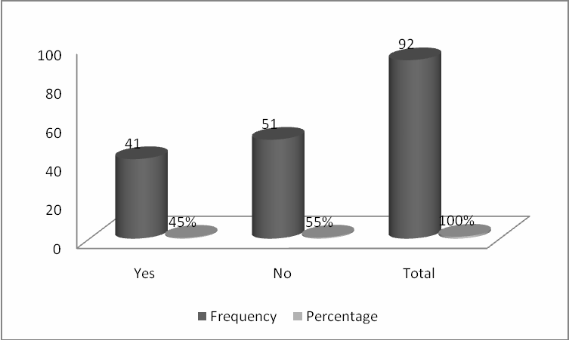

Source: (Field Data, 2019)

# Implementation of Strategies consistency with the needs of the beneficiaries

The study sought to establish whether strategy implementation at the Foundation was in line with the needs of the beneficiaries at the Wau foundation. From the findings, 61% answered “yes” while 39% answered “No” as shown on figure 4.4 below. For those who answered yes, they indicated that during strategy formulation, they indicated that the strategies were formulated in line with aspirations of the beneficiaries. For those who answered no, they were not involved in strategy formulation hence did not specifically know whether the implementation was consistent with the strategy formulated.

# Figure 4.6: Strategies Implementation consistency with the needs of the beneficiaries

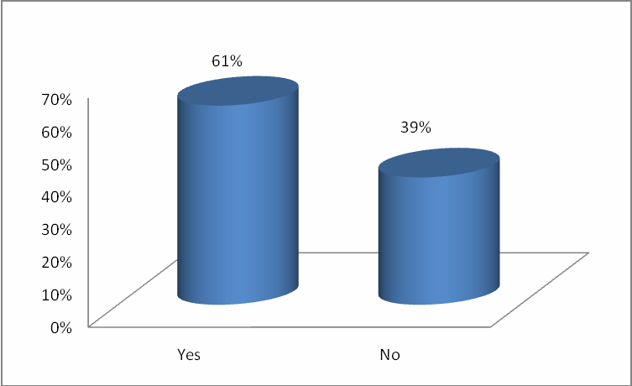

Source: (Field Data, 2019)

# Stakeholders Involvement in Strategies implementation

The study sought to establish the extent to which the stakeholders were involved in strategy implementation at the foundation. From the research findings, 85% said yes and 15% said No as shown on figure 4.5 below. Stakeholders were key partners in strategy implementation at the Foundation. Some stakeholders provided funding while others provided technical support hence their involvement was key for the success of project implementation at the Foundation.

# Figure 4.7: Stakeholders Involvement in Strategies implementation

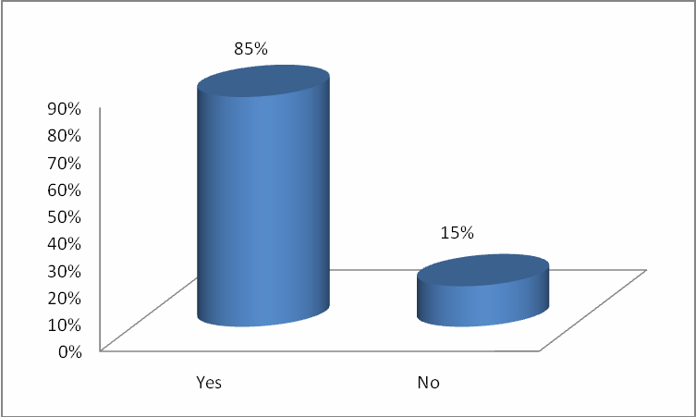

Source: (Field Data, 2019)

# Effectiveness of the Process of Strategy Implementation

The study sought to establish how effective the process of strategy implementation at the Foundation was. From the findings 21% said it was very effective, 38 % said it was effective 28% said it was moderately effective,10% said it was less effective, and 3% said it was not effective at all as shown on figure 4.6 below.

# Figure 4.8: Effectiveness of the Process of Strategy Implementation

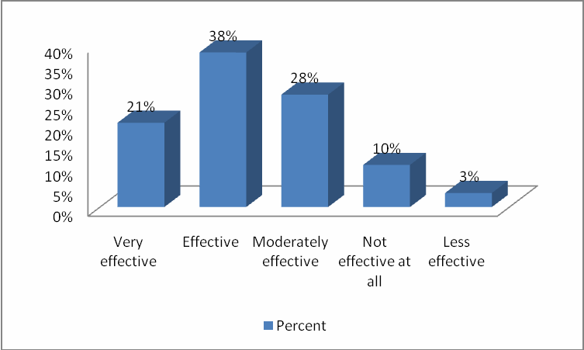

Source: (Field Data, 2019)

# Funding

* + 1. Sufficiency of Financial Support from donors

The study sought to establish whether the Children of Wau got enough financial support from donors for the implementation of its projects. From the findings 71% said yes and 29% said No as shown on figure 4.7. Those who said yes attributed to the degree to which the Foundation was able to deliver on its strategic objectives. From records at the Foundation, it was ascertained that the Foundation almost met between 80-95% of its strategic goals in any one given year. This shows the extent to which the Foundation received funding to run its projects.

# Figure 4.9: Sufficiency of Financial Support from donors

Source: (Field Data, 2019)

* + 1. Conditions of the funding

The study sought to establish whether funding availed by the donors had conditions on their applicability and whether no money can be spend outside the budget. From the findings 79% said yes and 21% said No as shown on figure 4.8 below. Like any other NGO, the Wau Children Foundation was guided by a budget which was prepared in advance for the attention of financial partners. The financial partner’s availed funds as per the budget and as such little could be spend outside the budget. This therefore meant that the expenditure had to strictly follow he budget.

# Figure 4.10: Conditions of the funding

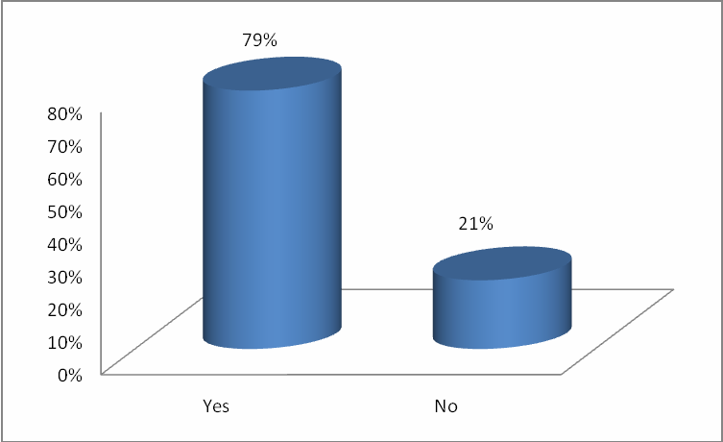

Source: (Field Data, 2019)

* + 1. Effects of Funding on the Implementation of Projects

The study sought to establish the effects that funding had on the implementation of projects at the Foundation. Several statements were fronted to which the respondents were to indicate their extent of agreement with each statement. The study then computed mean and standard deviation to aid in the analysis. The findings, on the question as to whether Funding had dictated the kind of projects to undertaken at the Foundation, the mean was 3.1584 with a standard deviation of 1.6501. On whether funding had slowed down the speed with which projects were implemented at the Foundation, the mean was 3.8936 with a standard deviation of 0.9364. On whether funding had limited the scope of the Foundation’s projects, the mean was 3.9174 with a standard deviation of 0.8173. the recorded means are slightly above three meaning that the respondents responses ranged from moderately agree to agreeing with the various statements.

# Table 4.6: Effects of Funding on the Implementation of Projects

|  |  |  |
| --- | --- | --- |
| Statement | Mean | Standard  Deviation |
| Funding has dictated the kind of projects to undertaken at the  Foundation | 3.1584 | 1.6501 |
| Funding has slowed down the speed with which projects are  implemented at the Foundation | 3.8936 | 0.9364 |
| Funding has limited the scope of the Foundation’s projects | 3.9174 | 0.8173 |

Source: (Field Data, 2019)

* + 1. Extent to Which Funding Had Affected Project Implementation

The study further sought to establish the extent to which funding had affected project implementation at the Foundation. From the findings, 34% of the respondents indicated that funding affected project implementation to a great extent, 31% to a moderate extent, 17% to less extent, 14% o very great extent and 3% to no extent.

# Figure 4.11: Extent to Which Funding Had Affected Project Implementation

Source: (Field Data, 2019)

# Training

The study sought to establish whether training affected project implementation at the Foundation. Asked whether the Foundation’s employees were conversant with their core duties, majority 69% of the respondents indicated that the employees were conversant with their core duties while 31% indicated that the employees were not conversant with their core duties. These findings are well illustrated in the figure below. For those who answered yes, they explained that the employees were offered special training which equipped them with the necessary skills to enable them deliver on their job duties. For those who indicated no, they felt that the Foundation at times asked them to do some duties which were beyond their scope.

# Figure 4.12: Training

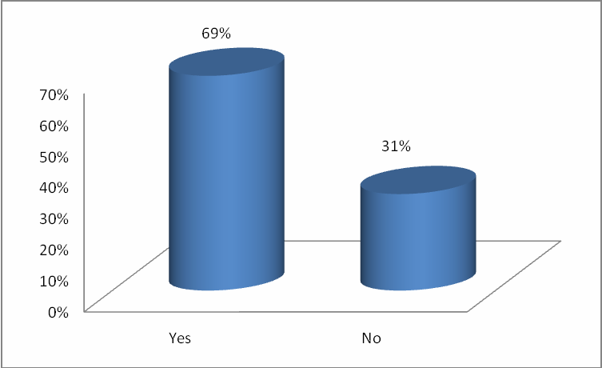

Source: (Field Data, 2019)

* + 1. Training Staff of Specialized Skills

The study sought to establish whether the Foundation trained its staff for specialized skills to equip them with the required skills to deliver on their duties. From the findings, 78% of the respondents indicated that the Foundation offered its employees training on how to run the affairs of the Foundation while 22% indicated that no training was offered. For those who indicated that some specialized training was offered, they indicated that this was offered through induction process and on the job training where employees worked under someone senior who taught then on what they were supposed to undertake.

# Figure 4.13 Training Staff of Specialized Skills

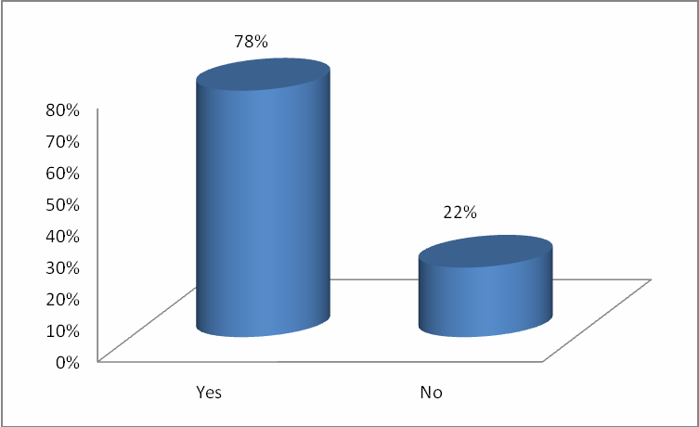

Source: (Field Data, 2019)

* + 1. Effectiveness of the trainings offered

The study sought to establish how effective the training offered to staff was. From the findings of the study, 41% of the respondents indicated that it was effective, 38% indicated that it was moderately effective, 10% said it was very effective, 7% said it was not effective while 3% indicated that it was less effective.

# Figure 4.14: Effectiveness of the trainings offered

Source: (Field Data, 2019)

# 4.6 Organization Structure

The study further sought to establish whether the organization structure of Wau Children Foundation affected the strategy implementation process. First, the respondents were asked to indicate whether the existing organization structure affected strategy implementation. From the findings, 83% of the respondents answered “yes” while 17% answered “no”. The respondents indicated that the organization structure was lean to eliminate duplication of roles and at the same time speed up the process of decision making. Some respondents however indicated that at times the decisions made were not very strong and were biased.

# Figure 4.15: Organization Structure

Source: (Field Data, 2019)

To substantiate these claims, several statements were fronted to the respondents to which they were to indicate their level of agreement. From their responses, the study computed mean and standard deviations. Asked whether the organization structure allowed timely decision making, the mean was 4.3218 with a standard deviation of 0.5184. On the organization structure allowing quality decision making, the mean was 2.9154 with a standard deviation of 1.6157 and on whether there was duplication of roles in the organization, the mean was 3.9456 with a standard deviation of 1.0548. These findings indicate that the organization structure was optimal as there was no duplication of roles and it allowed timely decision making.

# Table 4.7: Organization Structure

|  |  |  |
| --- | --- | --- |
| Statement | Mean | Standard  Deviation |
| The organization structure allows timely decision making | 4.3218 | 0.5184 |
| The organization structure allows quality decision making | 2.9154 | 1.6157 |
| The organizational structure has no duplication | 3.9456 | 1.0548 |

Source: (Field Data, 2019)

4.6.1 Extent that organizational structure affected project implementation

The study sought to establish the extent to which organizational structure affected project implementation at the Foundation. Majority of the respondents were indifferent indicating that it affected it to a moderate extent, 31% to great extent, 17% to very great extent, 10% to less extent and 3% to a no extent.

# Figure 4.16: Extent that organizational structure affected project implementation

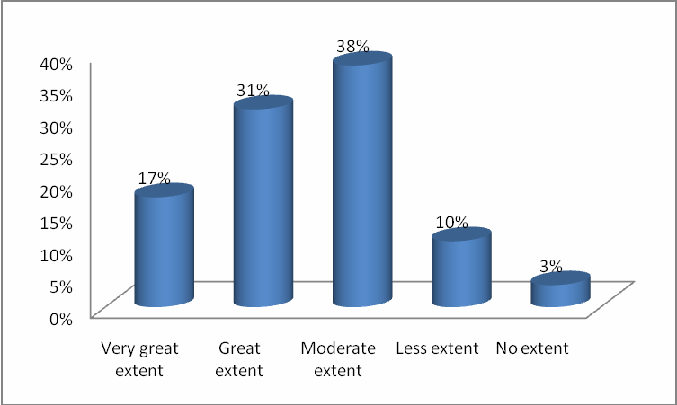

Source: (Field Data, 2019)

# Stakeholders Involvement

The study sought to establish whether stakeholder’s involvement affected project implementation at the Foundation. From the findings, majority of the respondents 81% indicated that stakeholder involvement affected project implementation at the Foundation while 19% said that it did not affect project implementation. The study noted that stakeholder involvement improved the accuracy and speed of project implementation at the Foundation. Their involvement meant that projects were implemented as planned without delays.

# Figure 4.17: Stakeholders Involvement

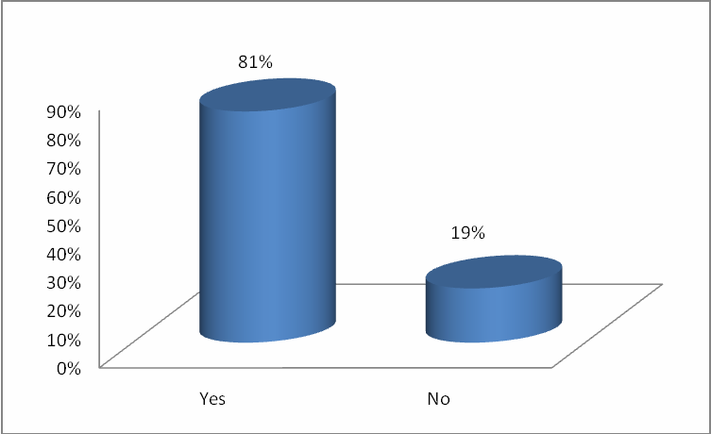

Source: (Field Data, 2019)

* + 1. Ways in which the stakeholders were involved.

The study sought to establish ways in which the stakeholders were involved in project implementation at the Foundation. The respondents indicated that stakeholders were involved in different ways. For the beneficiaries, they were involved by accepting to work hard with the resources provided to make sure that they were successful in life. For the donors, they were involved through audits and providing technical support whenever they could to ensure project success.

* + 1. Extent to which stakeholder involvement affected project implementation

The study sought to establish the extent to which stakeholder involvement affected project implementation at the Foundation. From the findings, majority of the respondents 938%) indicated that it affected to a great extent, 31% to a moderate extent, 14% to less extent, 10% to a very great extent while 7% to no extent.

# Figure 4.18: Extent to which stakeholder involvement affected project implementation

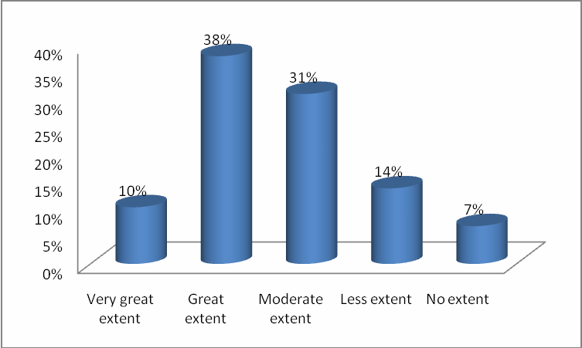

Source: (Field Data, 2019)

# CHAPTER FIVE: SUMMARY OF FINDINGS, CONCLUSIONS AND RECOMMENDATIONS

# Introduction

This chapter provides the summary of the findings from chapter four, and also gives the conclusions and recommendations of the study based on the objectives of the study. The objective of this study was to determine the factors affecting successful implementation of projects in Non-Governmental organizations within the urban slums in Kenya using a case of children of Wau Foundation. This study was guided by the following specific research objectives: finding out how funding affected implementation of projects of Children of Wau Foundation; establishing the effect of training on implementation of projects of Children of Wau; establishing the effects of organization structure on implementation of projects of Children of Wau Foundation; and establishing the effects of stakeholder relationships on the implementation of projects of Children of Wau Foundation.

# Summary of the Findings

The study targeted a sample of 38 respondents out of which 29 filled and returned the questionnaires giving a response of 76.32%. The females made the majority of the respondents at 59% and the males at 41%. 41% had a Diploma followed by those who had a bachelors‟ degree at 38%. 55% of the respondents had worked with the NGO for between 6-10 years, 31% had worked with the NGO for between 1-5 years, 7% had worked with the NGO for 11-15 years and 3% each had worked with the NGO for between 16-20 years and above 21 years respectively.

On whether the strategy implementation was undertaken as a collective responsibility of every member of the Foundation. 55% answered “yes” while 45% answered “No”. On whether the strategies were implemented on time, 53% said yes while 47% said No. On whether there was accuracy in the implementation of strategies at the Wau foundation, 55% said No and 45% said yes. On whether strategy implementation at the Foundation was in line with the needs of the beneficiaries at the Wau foundation, 61% answered “yes” while 39% answered “No”.

On the extent to which the stakeholders were involved in strategy implementation at the foundation, 85% said yes and 15% said no. On how effective the process of strategy implementation at the Foundation was, 21% said it was very effective, 38 % said it was effective 28% said it was moderately effective,10% said it was less effective, and 3% said it was not effective. On whether the Children of Wau got enough financial support from donors for the implementation of its projects, 71% said yes and 29% said No. On whether funding availed by the donors had conditions on their applicability and whether no money could be spend outside the budget, 79% said yes and 21% said No.

On the question as to whether Funding had dictated the kind of projects to undertaken at the Foundation, the mean was 3.1584 with a standard deviation of 1.6501. On whether funding had slowed down the speed with which projects were implemented at the Foundation, the mean was 3.8936 with a standard deviation of 0.9364. On whether funding had limited the scope of the Foundation’s projects, the mean was 3.9174 with a standard deviation of 0.8173. On the extent to which funding had affected project implementation at the Foundation, 34% of the respondents indicated that funding affected project implementation to a great extent, 31% to a moderate extent, 17% to less extent, 14% o very great extent and 3% to no extent.

Asked whether the Foundation’s employees were conversant with their core duties, 69% of the respondents indicated that the employees were conversant with their core duties while 31% indicated that the employees were not conversant with their core duties. On whether the Foundation trained its staff for specialized skills to equip them with the required skills to deliver on their duties, 78% of the respondents indicated that the Foundation offered its employees training on how to run the affairs of the Foundation while 22% indicated that no training was offered. The study sought to establish how effective the training offered to staff was. From the findings of the study, 41% of the respondents indicated that it was effective, 38% indicated that it was moderately effective, 10% said it was very effective, 7% said it was not effective while 3% indicated that it was less effective.

On whether the existing organization structure affected strategy implementation 83% of the respondents answered “yes” while 17% answered “no”. Asked whether the

Organization structure allowed timely decision making, the mean was 4.3218 with a standard deviation of 0.5184. On the organization structure allowing quality decision making, the mean was 2.9154 with a standard deviation of 1.6157 and on whether there was duplication of roles in the organization, the mean was 3.9456 with a standard deviation of 1.0548. On whether stakeholder’s involvement affected project implementation at the Foundation, majority of the respondents 81% indicated that stakeholder involvement affected project implementation at the Foundation while 19% said that it did not affect project implementation.

The respondents indicated that stakeholders were involved in different ways. For the beneficiaries, they were involved by accepting to work hard with the resources provided to make sure that they were successful in life. For the donors, they were involved through audits and providing technical support whenever they could to ensure project success. On the extent to which stakeholder involvement affected project implementation at the Foundation, majority of the respondents 38% indicated that it affected to a great extent, 31% to a moderate extent, 14% to less extent, 10% to a very great extent while 7% to no extent.

# Conclusions

Strategy implementation was undertaken as a collective responsibility of every member of the Foundation. The respondents indicated that the process of strategy formulation was undertaken by the top management while during implementation, duties were assigned to all employees according to their job descriptions and ability to execute them. This is because the implementation process involves the collective wisdom, knowledge, and even subconscious minds of the collaborators of the organization.

The study also established that the strategies were implemented on time. The respondents explained that strategy implementation was influenced by several factors key among them the availability of financial resources to see the strategy implementation to the end. The respondents indicated that at times, the partners delayed in availing the pledged support thus dragging the implementation of strategies in the Foundation. The study also established that strategy implementation was accurate. The respondents indicated that the accuracy of strategy implementation was to a great extent influenced by availability of

Financial and human resources. They indicated that insufficiency of resources reduced the accuracy in implementation. The respondents also indicated that senior management’s involvement in strategy implementation increased the level of accuracy in strategy implementation as they clearly knew of the expected outcome and how to get there during strategy formulation. The study also established that project implementation was consistence with the needs of the beneficiaries. The respondents indicated that during strategy formulation, strategies were formulated in line with aspirations of the beneficiaries. The study also established that project implementation at the Foundation was very effective. From records at the Foundation, it was ascertained that the Foundation almost met between 80-95% of its strategic goals in any one given year. This shows the extent to which the Foundation received funding to run its projects. Funding affected project implementation at the Foundation to great extent.

The study concludes that the Foundation trained its staff for special skills to enable them deliver on their job descriptions. Respondents indicated that some specialized training was offered, they indicated that this was offered through induction process and on the job training where employees worked under someone senior who taught then on what they were supposed to undertake.

The study also concludes that the organization structure of Wau Children Foundation affected the strategy implementation process. The respondents indicated that the organization structure was lean to eliminate duplication of roles and at the same time speed up the process of decision making. Some respondents however indicated that at times the decisions made were not very strong and were biased.

The study also concludes that stakeholder’s involvement affected project implementation at the Foundation. The study noted that stakeholder involvement improved the accuracy and speed of project implementation at the Foundation. Their involvement meant that projects were implemented as planned without delays. The stakeholders were involved in different ways. The study also established that stakeholders were involved in strategy implementation. Stakeholders were key partners in strategy implementation at the Foundation. Some stakeholders provided funding while others provided technical support

Hence their involvement was key for the success of project implementation at the Foundation.

# Recommendations

The study recommends that the Foundation engages the stakeholders more to harmonize its goals and objectives with the aspirations of the stakeholders and reduce dissonance levels thereby increasing satisfaction. This will ensure that the stakeholders support the activities of the Foundation.

To enables employees deliver quality services, the study recommends that the Foundation hires qualified staff and in addition, it trains them to enable them deliver services optimally. Following the unique operations and accounting for NGOs, it is important that staff are trained on the operations for timely project implementation.

The study recommends that the Foundation involves stakeholders in all its strategic management right from strategic formulation to strategic evaluation. This will reduce the levels of resistance hence promote strategy implementation processes.

# Suggestions for Further Study

This study concentrated on factors affecting project implementation at the Wau Children Foundation. The study centered on key factors in the NGO sector. To allow for generalization, this study recommends that another study be carried out to establish factors affecting project implementation in Government organizations. This is specifically because Government organizations have a different operating environment from that one in NGOs.

# REFERENCES

Antill, J.M. (1974), *Project management: an overall concept,* I.E. Aust, Adelaide, Keynote Address to Project Management Symposium, South Australian Division

Bingi, P., Sharma, M.K. and Godla, J. (7999), Critical issues affecting an I;IZP implementation, *Information Systems Management, pp. 7-14*

Boyce D. and Haddad A. (2001). An Analysis of ONGOing and Completed Projects in Latin America and the Caribbean World Bank,

Bromilov et al, (1988) Empirical relation between the average construction time (T) and project cost C in the building construction industry

Brown, C. and Vessey, I. (1999), TRP Implementation approaches toward a contingency framework, *Proceedings* of *the International Conference on Information Systems,* pp. 411-16

Buckhout, s., Frey, e. and Nemec, J. Jr (1999), Making PROJECTS succeed: turning fear into promise, *IEEE Engineering Management Review*, pp. 116-23

Callaway, E (2000), *Entprojectsrise Resource Planning-Integrating Application and Projects Process Across the Entprojectsrise*, Computer Technology Research Corporation, Charleston, SC

Cooper, R.G. (1999), From experience: the invisible success factors in product innovation, *Journal of Product Innovation Management*, Vol. 16 pp.115-33

Cox, A., Healey, J. and Hoebink P. (1999), *Promises to the Poor: the Poverty Reduction Policies of European Development Cooperation Agencies and their Effectiveness,* forthcoming, Macmillan:

Davenport, T.H. (1998), Putting the ent projects rise into the ent projects rise system,

*Harvard Projects Review,* pp. 121-31

Dissertation, NYU School of Law 78-151 (2004)(Unpublished). Dissertation, NYU School of Law 78-151 (2004) (Unpublished).

Donaldson & Preston (1995). The stakeholder theory of the corporation: Concepts, evidence, and implications.

Dearden, James A., (1991). Efficiency in spatial negotiations Wood, D. and Jones, F.(1995), convergent stakeholder theory.

Joseph, H. (2007), Stakeholder Theory, Corporate Governance and Public Management.

What can the history of state-run enterprises teach us in the post-Enron era?

Heggie & Vickers, 1998, Road fund management and financing Economic Recovery Strategy for Wealth and Employment Creation (ERSWEC 2003-2007),

Chris Donnges, Geoff Edmonds and Bjorn Johannessen , (2007), Sustaining the Benefits of Improved Access,

Armstrong, M. (1996), *A Handbook on Personnel Management Practice,* 5th ed.

London: Kogan Page

Babalola, J.B. (2003) *Budget Preparation and Expenditure Control in Education.* In Babalola J.B. (ed) Basic Text in Educational Planning. Ibadan Awemark Industrial Printers

Beardwell and Helden (2001). *Human resources management.* Macmillan Indian. Beardwell, N. and Holden, B. (1993), *Managing for Success*, 2nd ed. England: Prentice

Hall Publisher

Black, S. E. and Lynch, L. M. (1996), *Human-Capital Investment and Productivity. The American Economic Review*, Vol. 86, No. 2

Bottomley, M. H. (1985). *Personnel Management,* London: Macdonalds and Vans Limited Pg. 168.

Bryan, Leslie A. (1990*), An Ounce of Prevention for Workplace Accidents, Training and Development* Journal, NY: USA Vol. 44, No.7

Cascio, Wayne F. (1989), *Managing Human Resources*, 2nd ed. New York: McGraw- Hill Book Company

Cole, G. A. (2002), *Personnel and Human Resource Management*, 5th ed. Continuum London: York Publishers

Connor, P. Haiman, T. Scolt, W. (1978): *Managing the modern organization*Bouston:

Houghton Mifflin Co. Pg. 65-70

david Osborne (1996) *Staff training and Assessment* (Cassel Publishers London. Decouza, David A. and Robbins, Stephen P. (1996) *Human Resource Practice*, 5th ed.

New York: John Wiley & Sons Inc.

Derek Torrington and Laura Hall (2000), *Human Resource Management-The inside out,*

4th ed. England: Prentice Hall Publisher

Druker, P. S. (1955): *The practice of Management,* London: Heinemann Pg. 71. Evans, J. R. and Lindsay, W. M. (1999), *The management and Control of Quality* 4th ed.

Cincinnati, Ohio: South-Western College Publishing 85

Neo et al. (2000), *Human Resource Management: Gaining Competitive Advantage*, 3rd ed. Boston, McGraw-Hill

Fagerlind, A. and Saha, L.J. (1997). *Education and National Developments*. New Delhi.

Reed Educational and Professional Publishing Ltd.

Flippo, E. B. (1980): *Personnel Management,* Auckland: McGraw Hill Int. Book Co. Pg.

199.

Gordon, M. (1992), *The Handbook on Manpower Planning*, 1st ed. UK: Blackwell Publishers

Kelly, K. (1994), *Motorola: Training for the Millenium. Business Week,* March 2008 Pp 158-168

Kenney et al, (1992) *Management Made Easy,* 1st ed. South Carolina: Omron Publishers Krietner, S. (1995), *The Good Manager’s Guide*, 1st ed. London: Synene Publishers Linda M. (2001), *An Introduction to Human Resource Management, theory and*

*practice,* New York: Pelgrave Macmillan Publishers

McGhee et al (1996), *Nature of Learning*, 1st ed. Boston: McGraw-Hill Book Company McKenna, E. and Vic Beech (2002), *Human Resource Management-A Concise Analysis*,

1st ed. UK: Date Publishing Company Ltd Training Policy document for Ghana Ports and Harbors Authority.

Mwita, J. I. (2000), Performance management model: A system-based approach to system quality. *The International Journal of Public Sector Management*, Volume 13, No. 1, pp. 19-37.

Myers, C. And PIGORS, P (1981): *Personnel Administration,* Auckland: McGraw Hill Int.

Odekunle, S.O. (2001). Training and Skill Development as Determinant of Workers‟ Productivity in the Oyo State Public Service. Unpublished Ph.D Thesis, University of Ibadan

Onasanya C. M. D. (2005). Effective Personnel Management and Industrial Relations. (CMD 2005) 206.

Oshinsanmi, J. (1982): *Cost Benefit of Training* Ascon *Journal of Management* Vol. No.

Pg. 18-20

Psacharopoulos, G and Woodhall, M. (1997) training for Development: An Analysis of Investment Choice. New York Oxford University Press

Rowley, J. (1995), Management development: new agenda for information professionals, Library Management, Vol. 16 No.1, pp.5-10

Rukunga J. K. (2003), Strategic Change Management in Kenya: Case of Nairobi Bottlers Ltd. Unpublished MBA Project University of Nairobi.

Russell, J. S., J. R. Terborg and Powers, M. L. (1985), Organizational performance and organizational level training and support. *Personnel Psychology*, Volume 38, Issue 4, pp. 849-863.

Sahinidis, A. G. and Bouris, J. (2008), Employee perceived training effectiveness relationship to employee attitudes. *Journal of European Industrial*

Sakamota, A. and Powers, P.A. (1995) Education and the dual labour market for Japanese men in *American Sociological Review*., 60 (2) P. 222-246.

Sathe, V. (2003). *Corporate entrepreneurship: Top managers and new business creation.*

Cambridge: Cambridge University Press.

Schiller, B.R (2002) *Essentials of Economics,* 4th ed. Boston: Mcgraw-Hill Schultz, T.W. (1971) *Investment in Human Capital*. New York. The Free Press.

Simpson, M., Tuck, N., Bellamy, S. (2004), Small business success factors: the role of education and training, Education + Training, Vol. 46 No.8/9, pp.481-9.

Small Business Skill Assessment (2009), Sharing successful business practice", research report, Small Firms Enterprise Development Initiative, Sheffield, .

Smith, A., Whittaker, J. (2009), Management development in SMEs: what needs to be done? *Journal of Small Business and Enterprise Development*, Vol. 5 No.2, pp.176-85.

Torrignton (2008). *Human Resource Management* (Pearson Education.

Ubeku, A. K. (1984). *Personnel Management in Nigeria* London: Macmillan Publishing Co. Pg. 270.

Zaccarelli, H. E. (1997) *Improving Employee Performance: Effective Training Strategies and Techniques.* London: Kogan Page 19

**APPENDICES**

# Appendix 1: Introduction Letter

**Peter Atem Anyuon**

P.O. Box;

Nairobi

5th February, 2020 Dear Sir/Madam,

RE: **REQUEST FOR PARTICIPATION IN A RESEARCH STUDY**

I am a final PGD student at Kenyatta University. My area of specialization is project management. I am currently undertaking a research thesis on “**FACTORS AFFECTING EFFECTIVE IMPLEMENTATION OF PROJECTS BY NGOS IN SOUTH SUDAN**

**CASE OF CHILDREN OF WAU FOUNDATION**”. **OF JOHNANNITER INTERNATIONAL ASSISTANCE**

I would be grateful if you could spare some time from your busy schedule and complete the enclosed questionnaire. All the information provided was used purely for academic purposes and was treated with utmost confidentiality.

Thank you for your cooperation. Yours faithfully,

# Peter Atem Anyuon

**PGD Student, Africa institute for project management studies in Nairobi**

# Appendix I: Questionnaire

Please tick as appropriate

# Demographic Information:

1. Gender:

Male ( ) Female ( )

1. What is your highest qualification achieved?

Diploma ( ) Degree ( )

Masters ( ) PhD ( ) others (please specify)

1. What is your current designation within the organization?

Chairman ( ) Managing Director ( ) Programme Manager ( ) Finance manager ( ) Project Manager ( ) Field Officer ( ) others (please specify)

1. How many years have you been in the NGO sector?

1 – 5 years ( ) 6 – 10 years ( ) 11 – 15 years ( ) 16 – 20 years ( ) above 21 years ( )

1. How many years have you been at the Children of Wau Foundation?

1 – 5 years ( ) 6 – 10 years ( ) 11 – 15 years ( ) 16 – 20 years ( ) above 21 years ( )

# SECTION A - IMPLEMENTATION OF STRATEGIES OF WAU FOUNDATION

1. The process of strategy implementation is taken as a collective responsibility of every member of the Foundation

Yes ( ) No ( ) Please explain your answer

1. The Foundation has always implemented strategies on time

Yes ( ) No ( ) Please explain your answer

1. The process of implementing strategies at the foundation has been accurate

Yes ( ) No ( ) Please explain your answer

1. Strategies‟ implementation at the Foundation is in line with the needs of the beneficiaries

Yes ( ) No ( ) Please explain your answer

1. Strategies implementation includes all stakeholders of the Foundation

Yes ( ) No ( )

1. How effective is the process of strategy implementation at the Foundation

|  |  |  |
| --- | --- | --- |
| Strongly Agree | ( ) Agree | ( ) |
| Neutral | ( ) Disagree | ( ) |
| Strongly Disagree | ( ) |  |

# SECTION B: FUNDING

1. Does the Children of Wau get enough financial support from donors for the implementation of its projects?

Yes ( ) No ( ) Please explain your answer

1. The funding availed by the donors have conditions on their applicability and no money can be spend outside the budget

Yes ( ) No ( ) Please explain your answer

1. Below are some of the effects of funding on the implementation of projects at the Children of Wau foundation. On a scale of 5-1 where 5= strongly agree, 4= agree, 3= neutral, 2= disagree and 1= strongly disagree, please indicate by ticking (√) the extent of your agreement with each statement.

|  |  |  |  |  |  |
| --- | --- | --- | --- | --- | --- |
| Statement | 5 | 4 | 3 | 2 | 1 |
| Funding has dictated the kind of projects to undertaken at  the Foundation |  |  |  |  |  |
| Funding has slowed down the speed with which projects  are implemented at the Foundation |  |  |  |  |  |
| Funding has limited the scope of the Foundation’s projects |  |  |  |  |  |

1. In general, please indicate the extent to which funding has affected project implementation at the Children of Wau Foundation.

|  |  |  |
| --- | --- | --- |
| Very great extent | ( ) Great extent | ( ) |
| Moderate extent | ( ) Less extent | ( ) |
| No extent | ( ) |  |

# SECTION C – TRAINING

1. The Foundation’s employees are conversant with their core duties?

Yes ( ) No ( ) Please explain your answer

1. The Foundations trains its staff of specialized skills to equip them with the required skills to deliver on their duties.

Yes ( ) No ( ) Please explain your answer

1. How effective have the trainings been in equipping the employees at the foundation with the necessary to deliver on their jobs?

Very effective ( ) Effective ( ) moderately effective ( ) Less effective ( ) Not effective ( )

# SECTION D - ORGANIZATION STRUCTURE

1. Does the organization structure at the Foundation affect strategy implementation?

Yes ( ) No ( ) Please explain your answer

1. Below are statements on the organizational structure of the Foundation. On a scale of 5-1 where 5= strongly agree, strongly agree, 4= agree, 3= neutral, 2= disagree and

1= strongly disagree, please indicate by ticking (√) the extent of your agreement with each statement on how it affects project implementation.

|  |  |  |  |  |  |
| --- | --- | --- | --- | --- | --- |
| Statement | 5 | 4 | 3 | 2 | 1 |
| The organization structure allows timely decision making |  |  |  |  |  |
| The organization structure allows quality decision making |  |  |  |  |  |
| The organizational structure has no duplication |  |  |  |  |  |

1. To what extent does organizational structure affect project implementation at the Foundation?

|  |  |  |
| --- | --- | --- |
| Very great extent | ( ) Great extent | ( ) |
| Moderate extent | ( ) Less extent | ( ) |
| No extent | ( ) |  |

# SECTION E - STAKEHOLDERS INVOLVEMENT

1. Does stakeholder involvement affect project implementation at the Foundation?

Yes ( ) No ( ) Please explain your answer

1. In what ways are stakeholders involved in strategy implementation at the Foundation?
2. To what extent does stakeholder involvement affect project implementation at the Foundation?

|  |  |  |
| --- | --- | --- |
| Very great extent  Moderate extent | ( ) Great extent  ( ) Less extent | ( )  ( ) |
| NO EXTENT | ( ) |  |